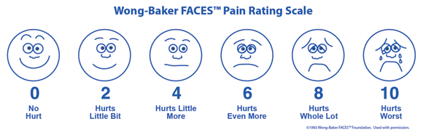

The Joint Commission on Accreditation of Healthcare Organizations (JCAHO) established pain assessment and management standards that went into effect on January 1, 2001. Under the standards, health care providers are expected to be knowledgeable about pain assessment and management, and facilities are expected to develop policies and procedures supporting the appropriate assessment of pain and the use of analgesics and other pain control interventions. For pain measurement, the standards recommended use of pain assessment tools and specifically named three scales for use, the 0-10 scale, the Wong-Baker FACES® Pain Rating Scale, and the verbal descriptor scale.

Since the JCAHO requirement, the Wong-Baker FACES® Pain Rating Scale was adopted as part of nursing documentation records in many hospital units, clinics, nursing homes, assisted living facilities and home health and hospice agencies across the United States. Practitioners are frequently uninformed about the reliability and validity of the FACES® Pain Rating Scale, even though the scale is widely used in the clinical setting. Pain assessment tools with strong evidence of reliability and validity are more likely to achieve quality patient outcomes.

Similarly, the Centers for Medicare and Medicaid Services have established pain assessment and intervention standards for home health care called Outcomes and Assessment Information Set (OASIS). Wong-Baker FACES® Pain Rating Scale is one of three tools recommended by OASIS.

Since its initial research and development in the early 1980s, Wong-Baker FACES® Pain Rating Scale has been used professionally in numerous clinical trials and research studies, books, journal publications, and other media. It is a popular choice for pain assessment in children and adults in the United States and worldwide. The tool has been translated in 29 languages. Professionals trust its simplicity, reliability and ease of use.

The Wong-Baker FACES® Foundation was established in 2009 and now administers licensure of the scale. Licensure makes it possible for the Foundation to ensure appropriate use of the scale, promote excellence in pain assessment and management, and nurture initiatives that Dr. Donna Wong envisioned, such as atraumatic care.

The tool must be administered as indicated in the brief but essential instructions. The patient must understand the tool and be able to communicate his pain rating with the Wong-Baker FACES® Pain Rating Scale.