Dear Caregiver,
Thank you for providing care for _______________. In an effort to have continuity and to know what is working to make him/her feel better, please keep a record during your time with him/her, using the following Wong-Baker FACES® Pain Relief Log.
- Enter the time of day, medications given, if any, and keep track of his/her pain and nausea by using a 0-10 rating or let him/her tell you how he/she is feeling. This will help us know if the medications he/she is taking for his/her symptoms are working well or if they need to be adjusted. If he/she takes medicine for pain or nausea, follow up in 45 minutes or so to see if he/she is having relief and make a note of that.
- If he/she is eating or drinking, write it down, not to keep a strict log of what he/she is taking in, but to have an idea of what he/she is enjoying and able to eat and drink.
- In the Caregiver’s Observations column, note what you are seeing or comments he/she is making, for instance, watching television, relaxed, sleepy, alert, uncomfortable, complaining of pain, laughing, etc.
- Keep this simple for yourself, while understanding the information you provide will improve his/her care and help people who follow you know what has happened.

-You may use the self-assessment tool below, asking which face most closely illustrates the pain experienced and record the number in the pain relief log.
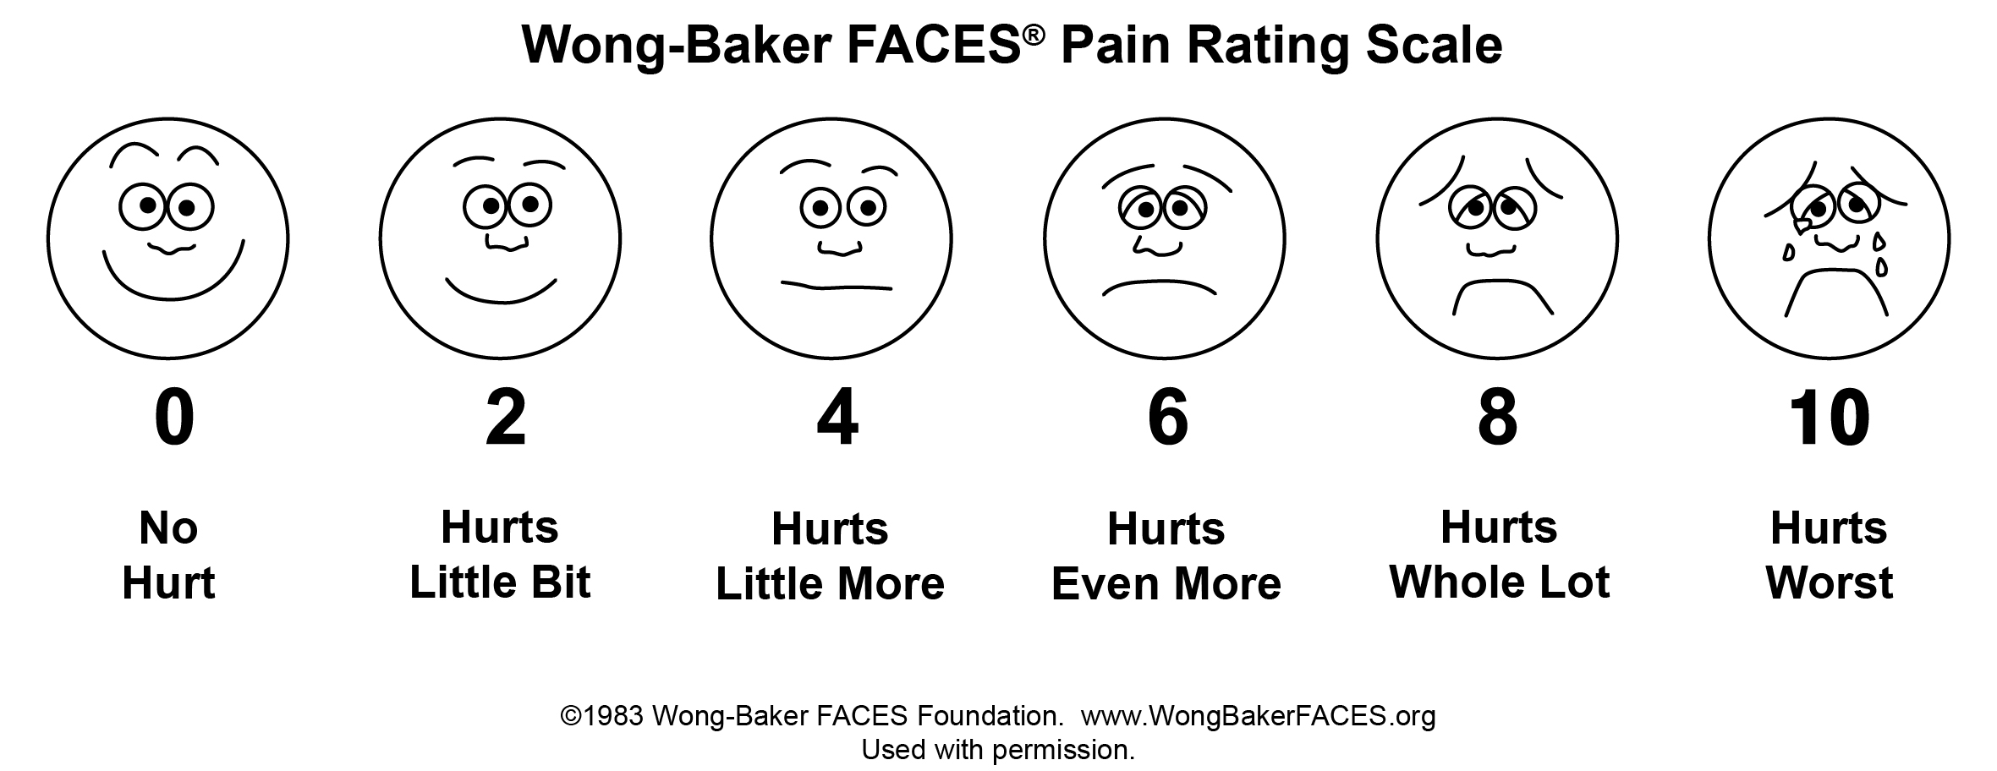

Wong-Baker FACES® Pain relief log

Patient Name
Date  TIMe | Medications administered | pain rating  (0-10) | nausea rating  (0-10) | food & beverage | Caregiver’s observations

